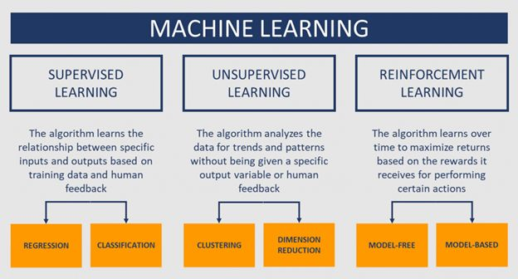

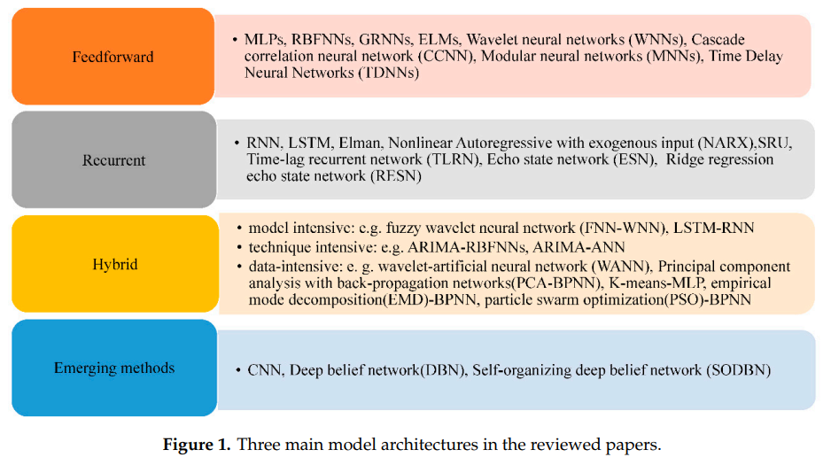

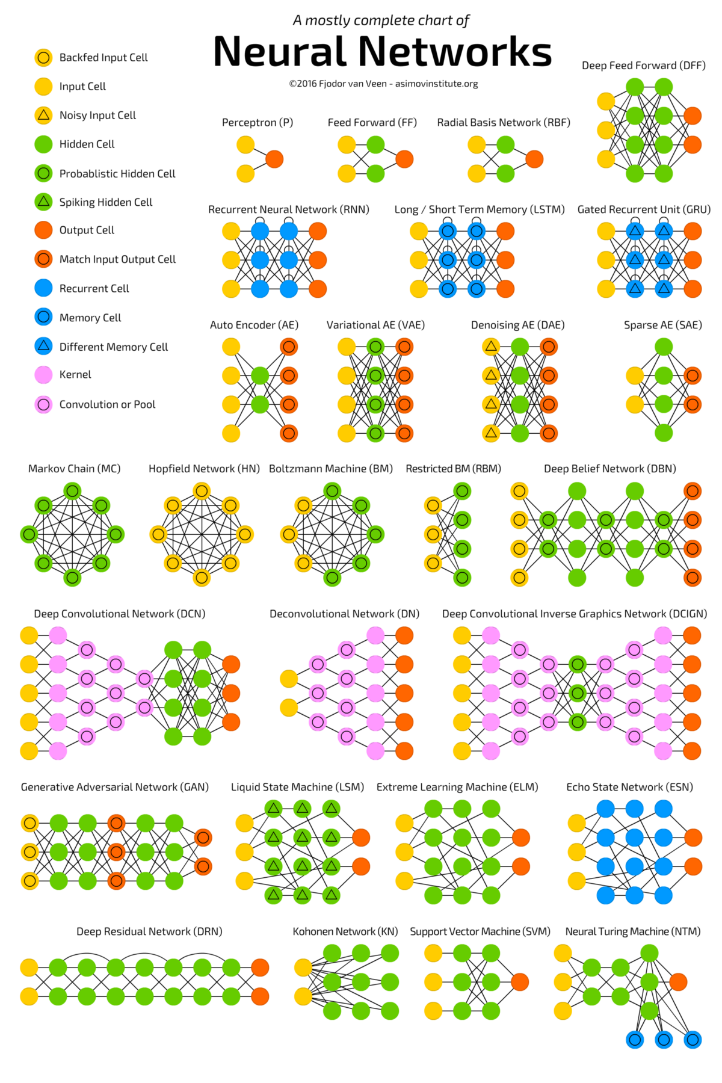

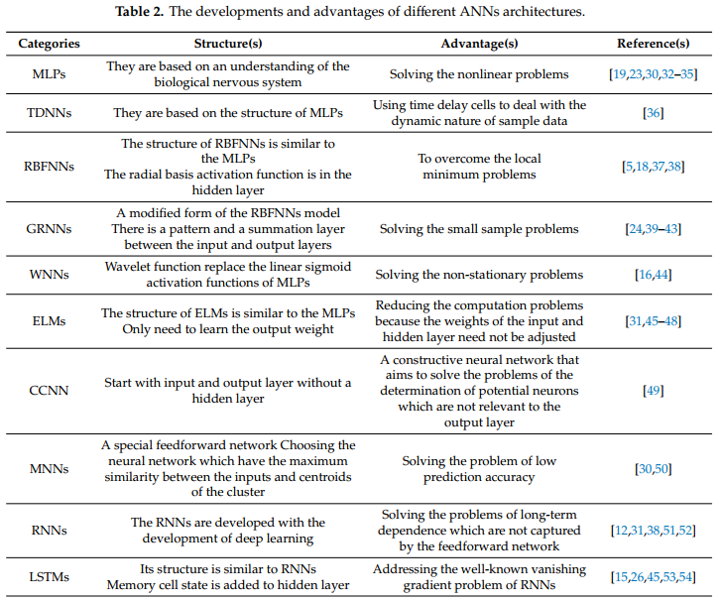

Beberapa metode riset NN tentang thermal runaway:

<https://doi.org/10.1109/TPEL.2020.3008194>

<https://doi.org/10.1109/TPEL.2022.3150026>

<https://doi.org/10.1109/TII.2020.3015555>

<https://doi.org/10.1149/MA2020-012429mtgabs>

<https://doi.org/10.1016/j.energy.2021.121266>